**A Database Mini Project Report**

**on**

**“EVENT REGISTRATION DATABASE SYSTEM”**

**Submitted to the**

**Savitribai Phule Pune University**

**In partial fulfillment for the award of the Degree of**

**Bachelor of Engineering**

**in**

**Information Technology**

**by**

**Rucha Shinde 33162**

**Shreeya Thigale 33168**

**Riddhi Toshniwal 33169**

**Under the guidance of**

**Prof. Sumitra Jakhete**



**Department Of Information Technology**

**Pune Institute of Computer Technology College of Engineering**

**Sr. No 27, Pune-Satara Road, Dhankawadi, Pune - 411 043.**

**2019-2020**



**CERTIFICATE**

**This is to certify that the mini project report entitled “Event Registration Database System” being submitted by Shreeya Thigale(33168), Riddhi Toshniwal(33169), Rucha Shinde(33162) is a record of bonafide work carried out by him/her under the supervision and guidance of Prof. Sumitra Jakhete in partial fulfillment of the requirement for TE (Information Technology Engineering) – 2015 course of Savitribai Phule Pune University, Pune in the academic year 2019-2020.**

**Date: 15/10/2019**

**Place: Pune**

**Guide Subject Coordinator Head of the Department**

**Principal**

**This Project Based Seminar report has been examined by us as per the Savitribai Phule Pune University, Pune requirements at Pune Institute of Computer Technology, Pune – 411043 on . . . . . . . . . . .**

**Internal Examiner External Examiner**

ACKNOWLEDGEMENT

I respect and thank Mrs. Sumitra Jakhete, for providing us an opportunity to do the project work and giving us all support and guidance which made me complete the project duly. I am extremely thankful to her for providing such a nice support and guidance, although she had busy schedule managing the college affairs.

I owe my deep gratitude to our project guide Dr. Emmanuel, who took keen interest on our project work and guided us all along, till the completion of our project work by providing all the necessary information for developing a good system.

I am thankful to and fortunate enough to get constant encouragement, support and guidance from all Teaching staffs of Information Technology which helped us in successfully completing our project work. Also, I would like to extend our sincere esteems to all staff in laboratory for their timely support.

Rucha Shinde 33162

Shreeya Thigale 33168

Riddhi Toshniwal 33169

**CONTENTS**

|  |  |  |
| --- | --- | --- |
| **Sr.No** | **TITLE** | **Page no** |
| **1.** | **Content’s Abstract** | **3** |
| **2.** | **Introduction** | **3** |
| **3.** | **Overview** | **4** |
| **4.** | **Background and Motivation** | **4** |
| **5.** | **Methodology** | **4** |
| **6.** | **Scope** | **4** |
| **7.** | **Requirements** | **4** |
| **8.** | **E-R Diagram** | **6** |
| **9.** | **Schema Diagram** | **6** |
| **10.** | **Relational Database Design** | **7** |
| **11.** | **Database Normalization** | **8** |
| **12.** | **Graphical User Interface** | **16** |
| **13.** | **Conclusion** | **17** |
| **14** | **References** | **18** |

**ABSTRACT**

In this project we are created one application which is easy to access user friendly. For this application we used the backend as MySQL DB to store the data which is used in the application and for the user interface we have used the HTML, CSS, Bootstrap, Javascript and JSP. Two kinds of people are able to use this application as user and the admin as well. The user is able to register for an event just a click away sitting at home and the admin is able to add or update/manage events accordingly.

**INTRODUCTION**

Various events take place in colleges and event management has always been a topic of concern. Maintaining registrations being a part of event management is always done manually. The data might not be organized properly Also, retrieving and updating registration details is difficult.

Thus our project is to simplify this task and make it more efficient. It makes registration process automated.

**OVERVIEW**

This report discusses the result of the work done in development of "Event Registration Database System on “JSP” Front-end Platform and “MySQL” as back-end Platform. At the development of an application JSP provides a good connecting facility between all pages, also the back-end MySQL is most important to save all the data related the application.

**Event Management System Module**

In EMS project we use PHP and MySQL database. It has two modules.

1. Admin/Organizer Module -
2. User/participant Module -

Admin Module

Dashboard: In this section, admin can see all detail in brief like listed categories, Total Events, Total Registered Users, Total Bookings, Total New Booking.

Category: In this section, admin manage event category (add and update).

Events: In this section, admin manage events (add and update).

View Bookings for each event: In this section, admin can view list of bookings of all events.

Admin can also update his profile, change password and other fields

User Module

In this module there is two types of user guest user and registered user.

Guest User: In this guest user can see only general information like about us, event details, contact details and new about events.

**BACKGROUND AND MOTIVATION**

The definition of our problem lies in manual system and a fully automated system.

**Manual system**

The system is very time consuming and lazy. This system is more prone to errors and sometimes the approaches to various problems are unstructured.

**Technical system**

With the advent of latest technology if we do not update our system then our business results in losses gradually with time. The technical systems contains the tools of latest trend i.e. computers printers, fax, Internet etc. The systems with this technology are very fast, accurate, user-friendly and reliable.

**OBJECTIVE**

Need of Event Registration System

* Convenience
* Better affordance
* Less errors
* Easy update and retreival
* Reduces redundancy

**METHODOLOGY**

To implement the above goals,the following methodology

needs to be followed:

* Design an Entity-Relationship Model Diagram to depict relations and working of database.
* Convert the Entity-Relationship Diagram to an effective
* Schema Diagram and normalize it to Boyce-Codd normal form.
* Prepare a connection framework to interact with the database using Servlet programming and various procedures and queries.
* Accept data from user and display data using front-end web applications developed using HTML,CSS,JSP and Bootstrap.
* Hence,create an effective flow of data and manage it.

**SCOPE OF PROJECT**

The scope of the project is clear to give a simple and attractive application to simplify the work as well as to reduce the efforts while doing it manually or we can say by doing it with old methods.

In this application we are able to save database of all registrations made by the user. In this way we can keep track of records without human interference.

Registered users can do following activity

* Register for the events.
* Update his/her own profile.
* Change Password.
* Can see all the details in brief like listed categories, Upcoming Events, Old events, (with event details) , his own registrations(with receipt/ticket).

**REQUIREMENTS**

|  |  |
| --- | --- |
| Operating System | Windows 10 |
| Interface | JDBC |
| Database | MySQL |
| User Interface Design | HTML, CSS, Bootstrap 4, Javascript, JSP |
| Web Browser | Google Chrome, IE8 |
| Server | Apache Tomcat 8.5 |
| Software | Mysql Workbench, Eclipse version-2018-09 |

**ER DIAGRAM**

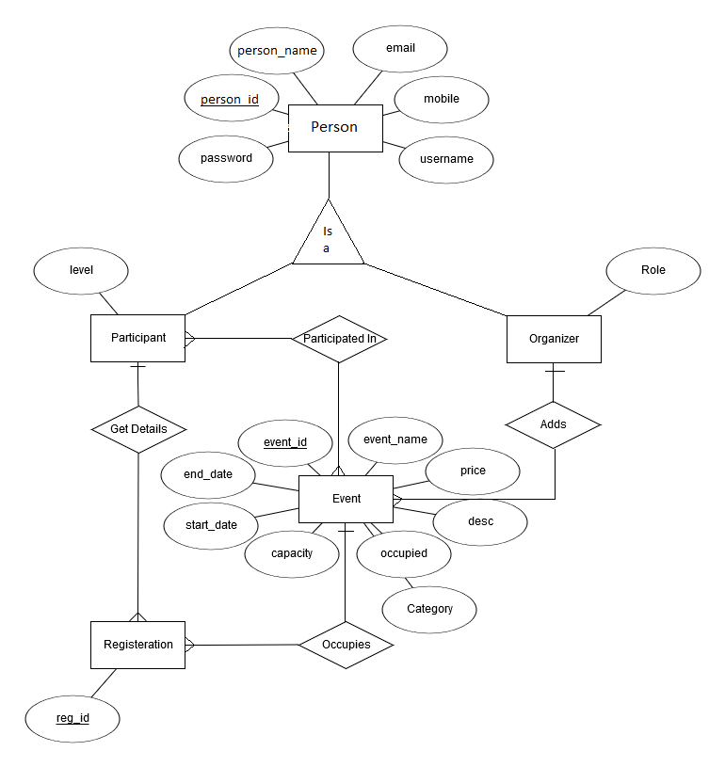

**SCHEMA DIAGRAM**

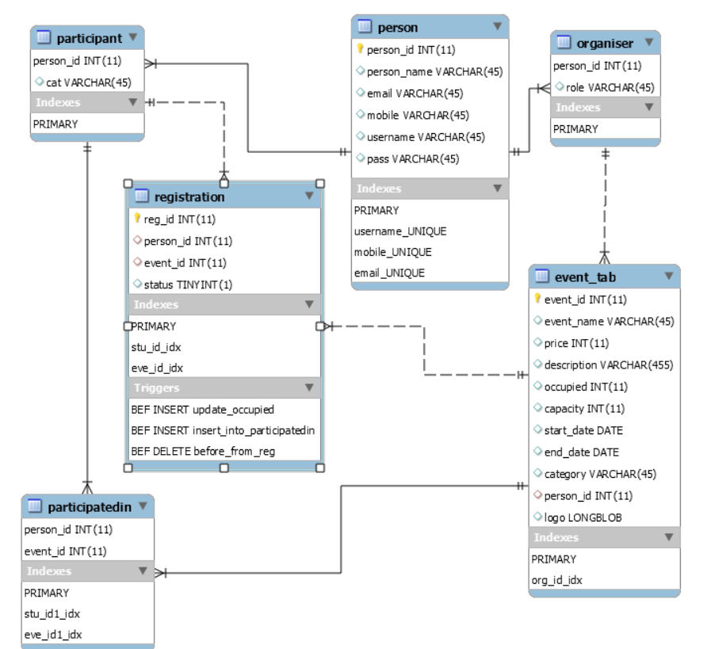

**7. RELATIONAL DATA BASE DESIGN**

1] Person:-

|  |  |  |  |  |  |
| --- | --- | --- | --- | --- | --- |
| person_id | person_name | Email | Mobile | Username | Password |
| Int(11)  Primary key | Varchar (25) | Varchar (25) | Int ( 11) | Varchar (45) | Varchar (45) |

2] Events Table:-

|  |  |  |  |  |  |  |
| --- | --- | --- | --- | --- | --- | --- |
| Event_id | Event_name | Price | description | Occupied | Capacity | Start Date |
| Int(11)  Primary Key | Varchar(45) | Int(11) | Varchar(455) | Int(11) | Int(11) | Date |

|  |  |  |  |
| --- | --- | --- | --- |
| Person_id | End_date | Category | Logo |
| Int(11) | Date | Varchar (25) | Blob |

3] Participant:-

|  |  |
| --- | --- |
| person_id | Category |
| Int(11)  Primary Key | Varchar(25) |

4]Organiser:-

|  |  |
| --- | --- |
| person_id | Role |
| Int (11) | Varchar(255) |

5]Registration:-

|  |  |  |  |
| --- | --- | --- | --- |
| Reg_id | Person_id | Event_id | Status |
| Int(11)  Primary key | Int(11) | Int(11) | Int ( 1) |

6]ParticipatedIn:-

|  |  |
| --- | --- |
| person_id | Event_id |
| Int (11) | Int(11) |

**DATABASE NORMALIZATION**

Database normalization can reduce data redundancy caused by insertion,deletion and updation anomalies and makes the data more meaningful.

**First Normal Form**

The rules for the table to be in first normal form are:

1. Single Values Atributes : Each column of the table should be single valued which means they should not contain multiple values.
2. Attribute domain should not change : In each column,the values stored must be of same type or kind.
3. Unique name for columns : To avoid confusion,each column must have a unique name.
4. Order doesn’t matter:-The rule says the order in which you store data in your table doesn’t matter.

**Example :**

Person

|  |  |  |  |  |  |
| --- | --- | --- | --- | --- | --- |
| person_id | person_name | email | Mobile | username | pass |

* This table is 1NF as each column has atomic values.
* The values stored in each column has same type , consider person_name attribute every record will have name as type varchar()
* Every column above has unique name
* The order of data in table does not matter.

**Second Normal Form**

The rules for table to be in second normal form are:-

1. The table should be in the First Normal Form.
2. There should be no partial dependency i.e any attribute of the table shouldn’t depend on a part of the primary key but depend on the whole primary key instead.

**Example :**

Person

|  |  |  |  |  |  |
| --- | --- | --- | --- | --- | --- |
| person_id | person_name | email | mobile | username | pass |

* The table is already in 1NF as discussed above.
* Also every non-prime attribute is not dependent on part of primary key but whole primary key, consider person_name depends on person_id completely and not partially.

**Third Normal Form**

The rules for the table to be in Third Normal Form are:-

1. It should be in Second Normal Form.
2. It should have no transitive dependency i.e. any non-prime attribute shouldn’t depend on any other non-prime attribute but only a prime attribute or primary key.

**Example :**

Person

|  |  |  |  |  |  |
| --- | --- | --- | --- | --- | --- |
| person_id | person_name | email | mobile | username | pass |

* The table is in 2NF as discussed above.
* Also every non-prime key is not dependent on other non-prime key, consider non-prime attribute email is not dependent on any other non-prime attribute of table.

**GRAPHICAL USER INTERFACE**

The application uses a GUI interface implemented in HTML,CSS and Bootstrap to communicate with user.Various features of the application are self-explanatory.Forms are easy to fill in and components can be added,removed and updated easily.

The application is very user friendly and uses a GUI interface implemented in JSP and HTML to Communicate with the user. Various features are self – explanatory. Forms are easy to fill in and components can be added, removed and updated very easily. Drop downs and radio buttons are used to display all the components at once so that user can see all the components of a Particular type at once. One can just select the component and modify and remove the component.(based on the access control of the person)

**SCREENSHOTS**

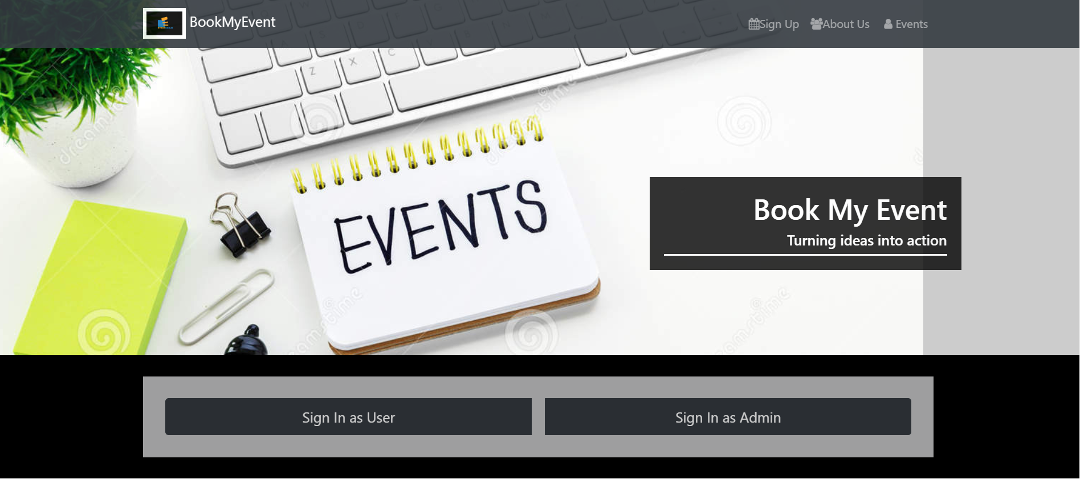





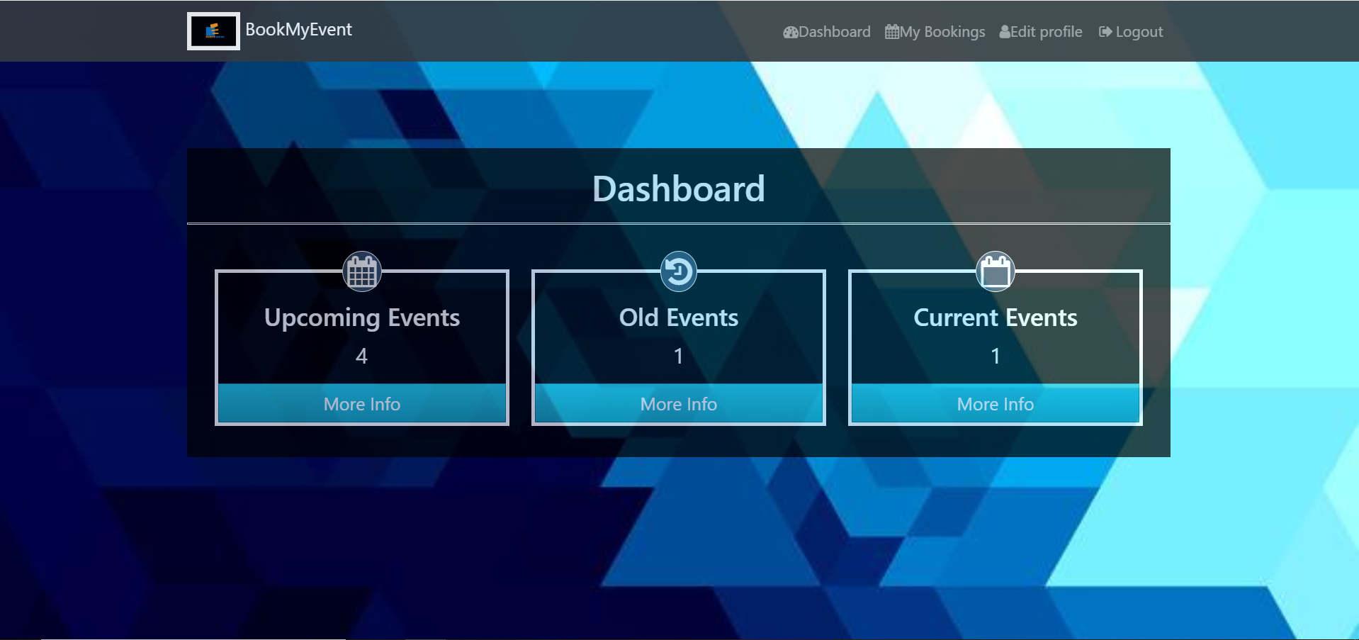

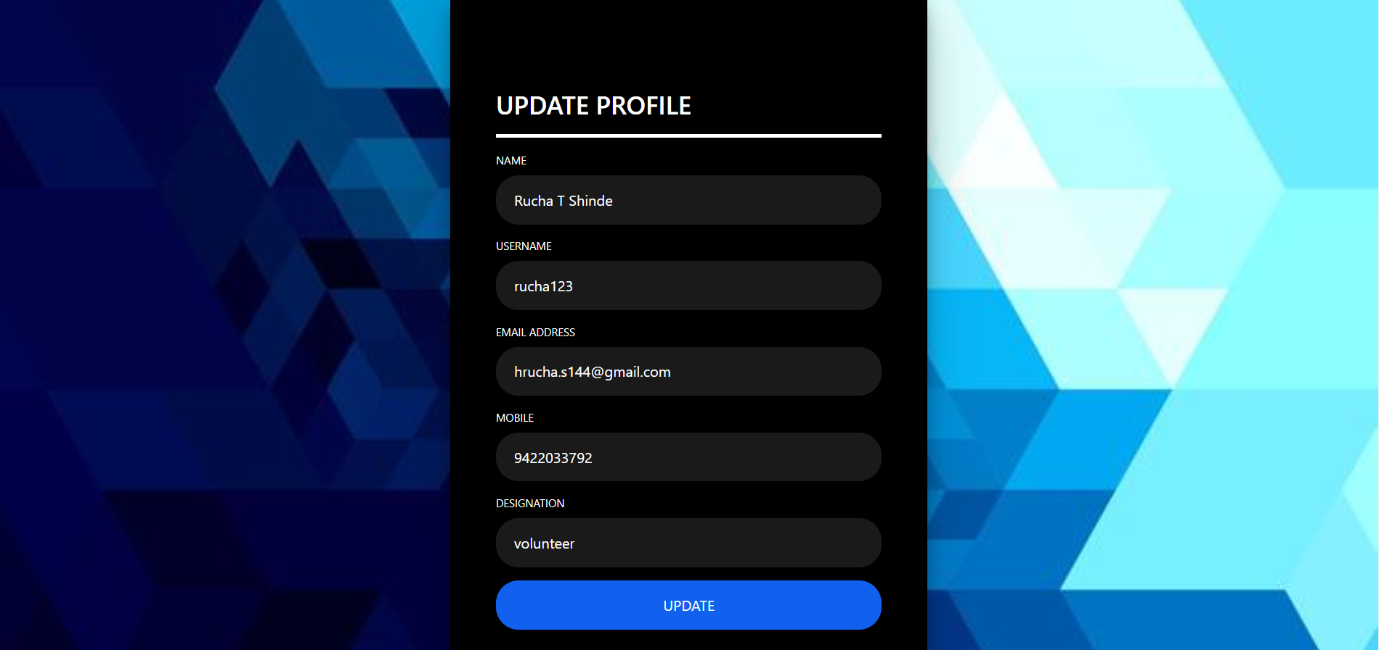

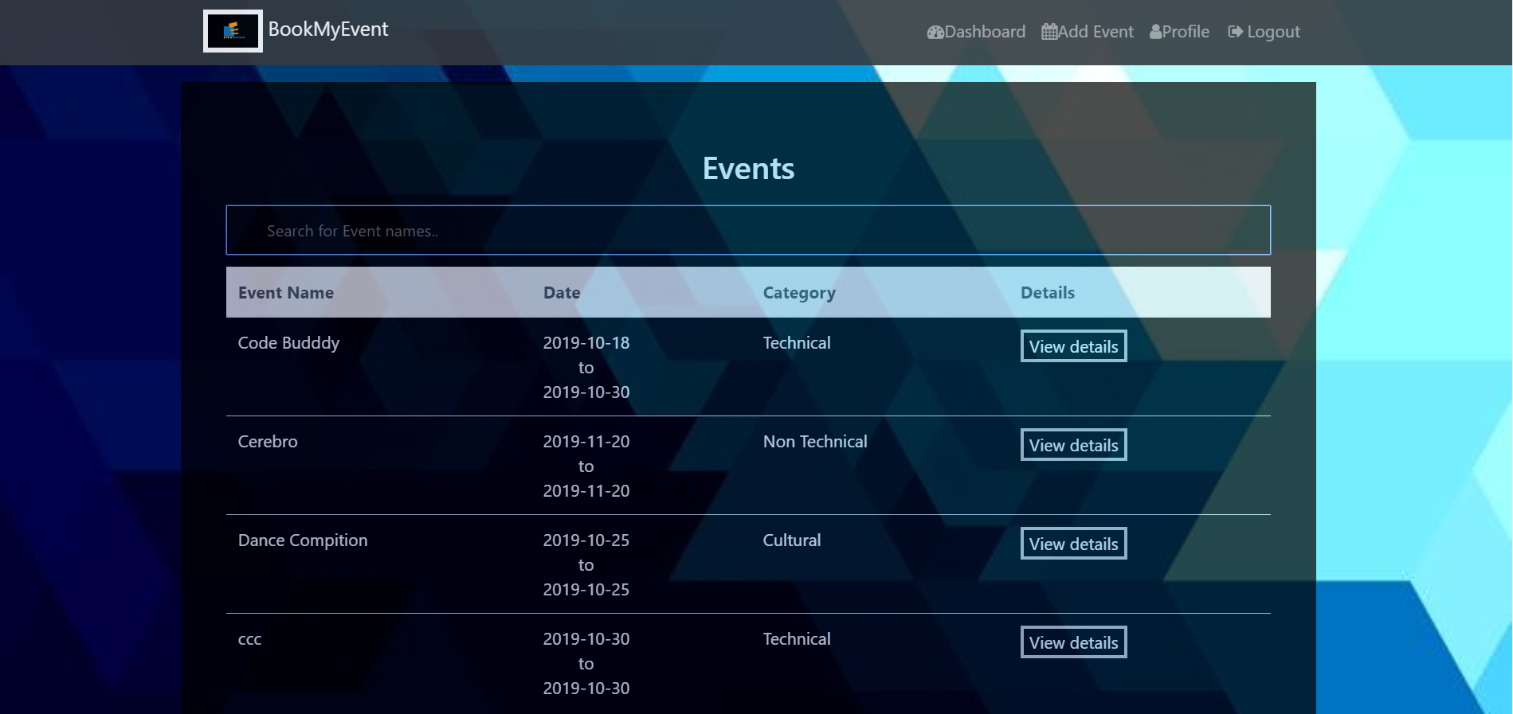

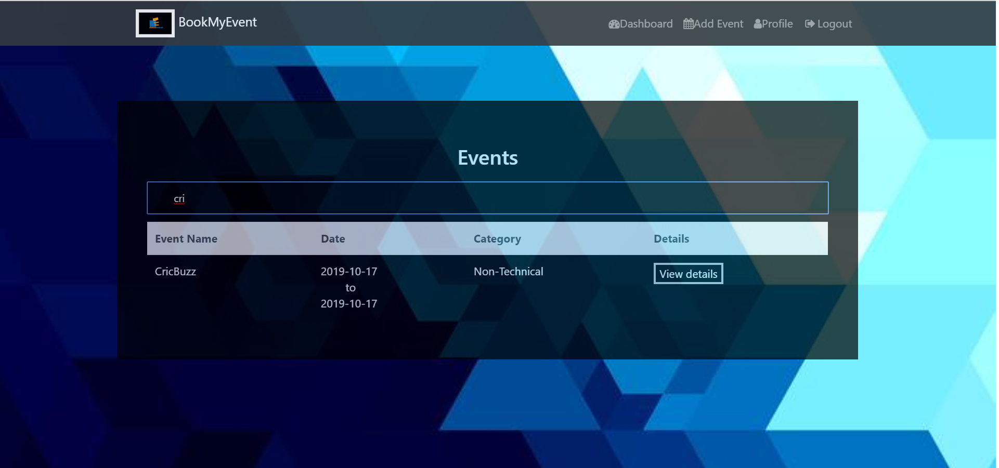

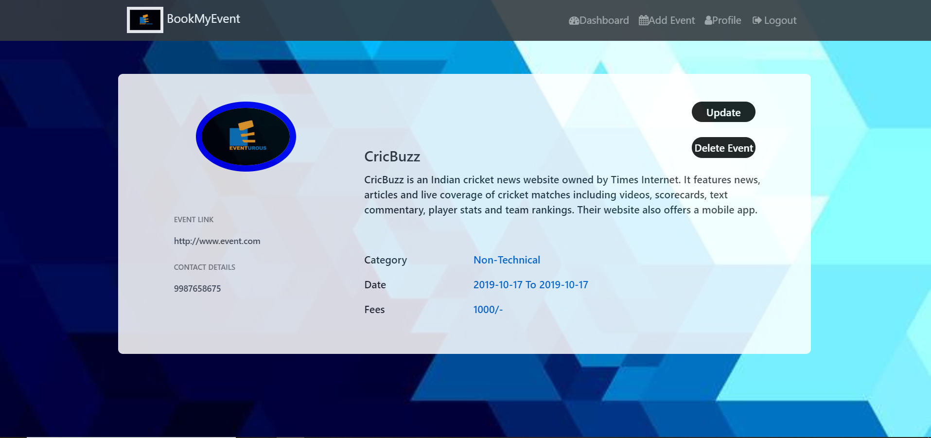

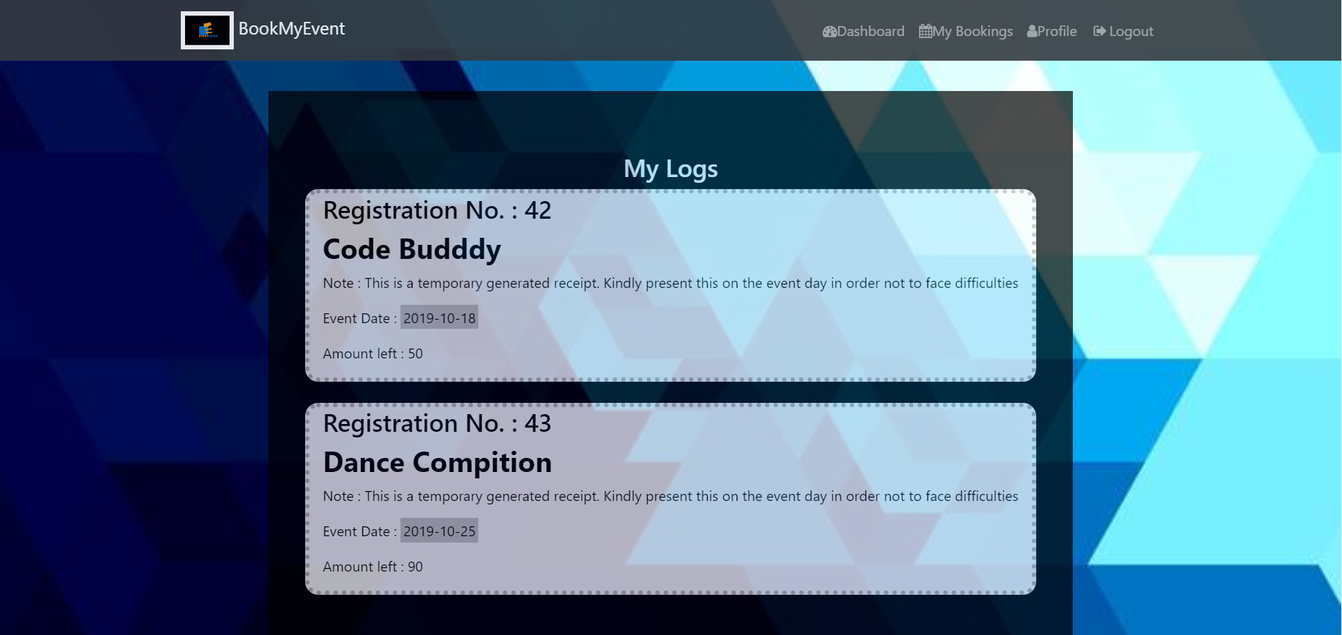

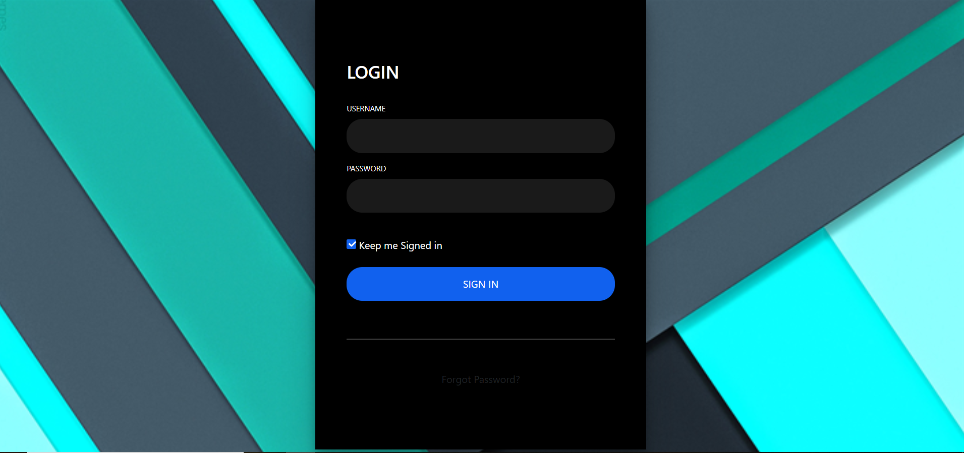

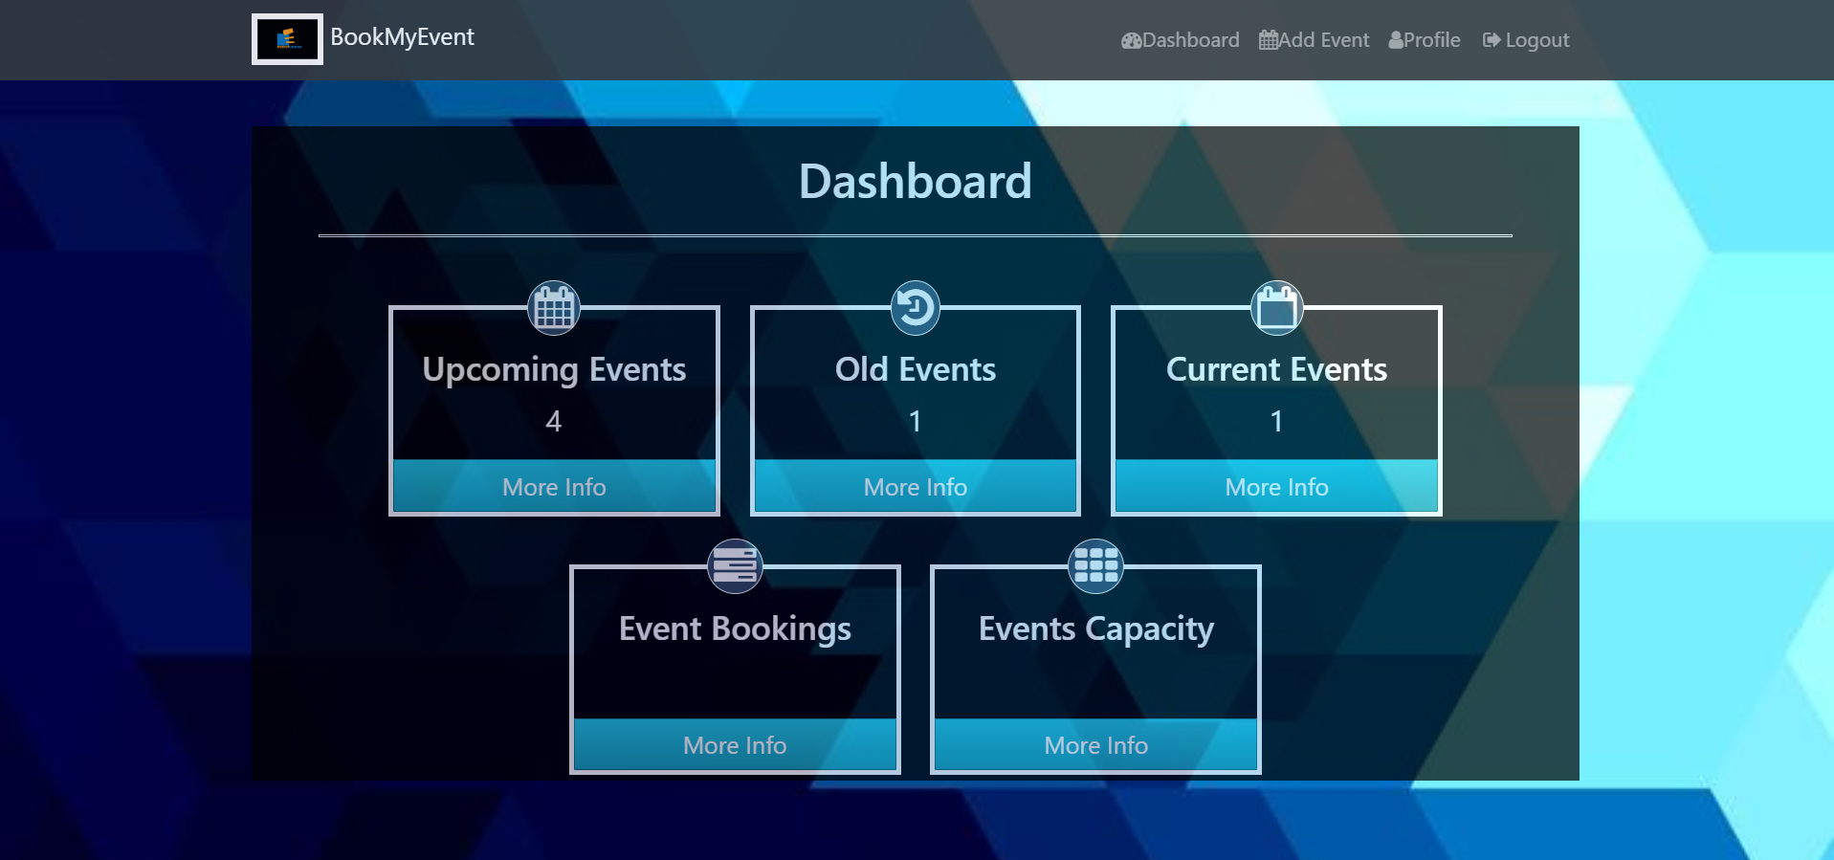



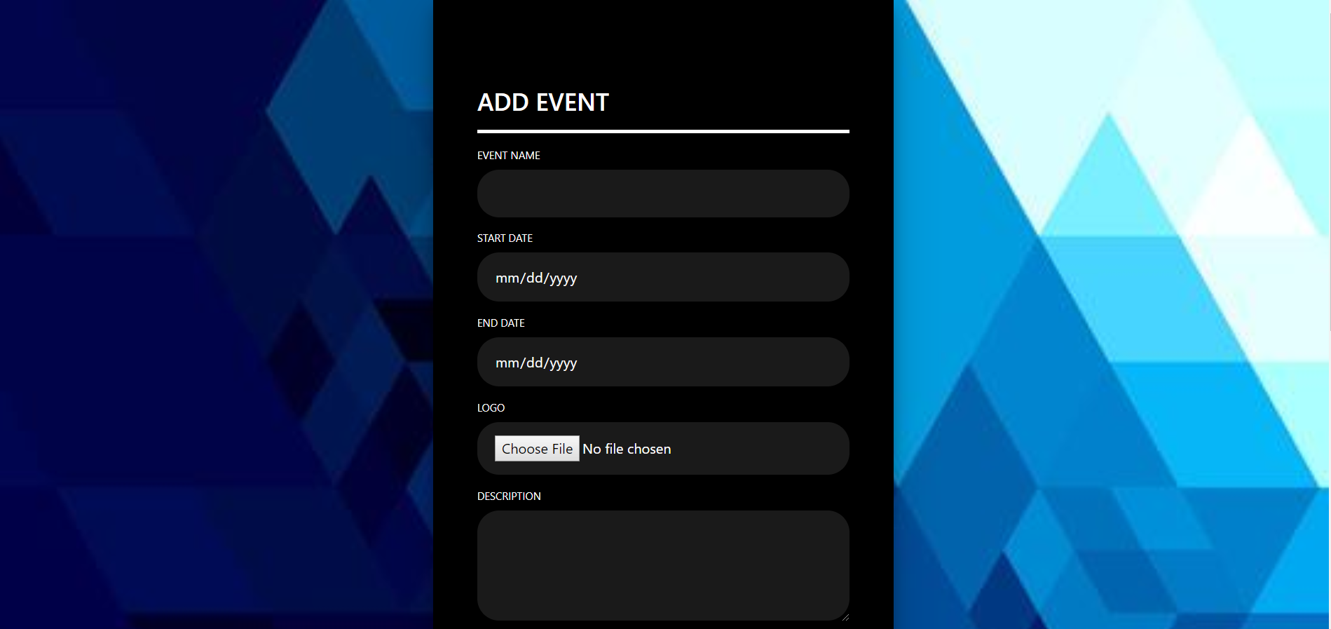

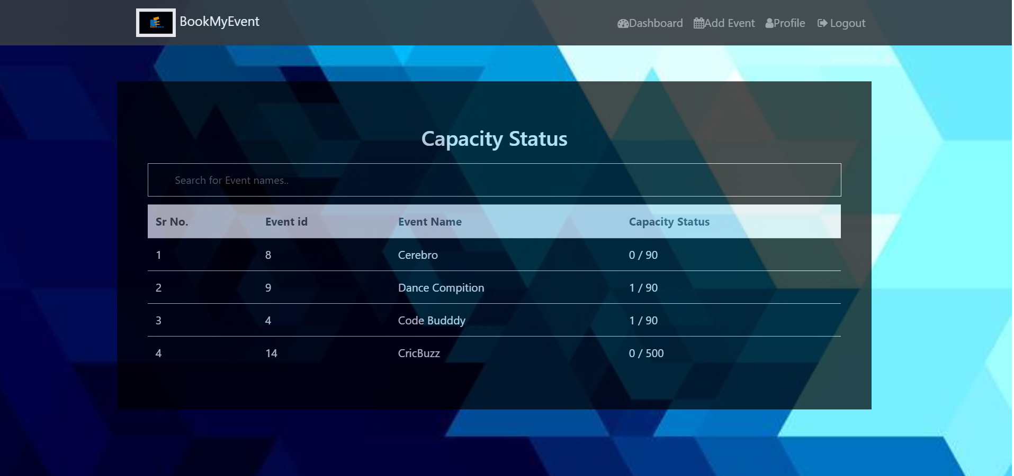

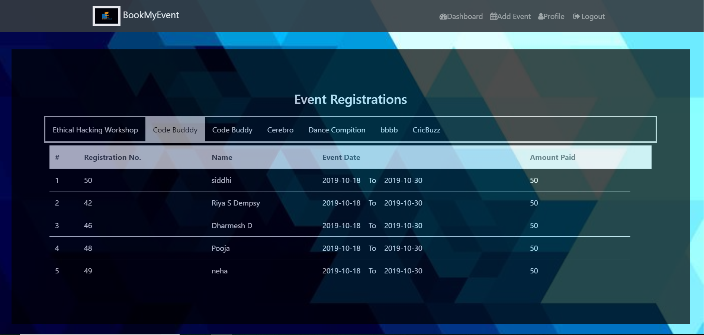

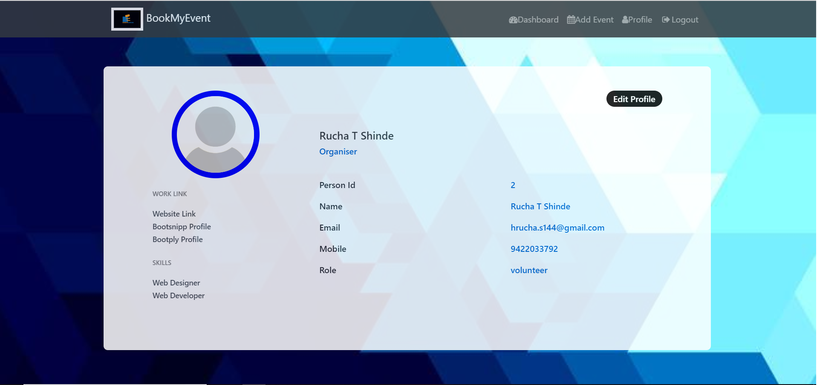

**CONCLUSION**

Thus we have successfully implemented online event registration database system which helps users to register for a particular event and he can keep track of his bookings. We have successfully implemented various functionalities of MySQL and JSP and created the fully functional database management System for Event Registration.

**REFERENCES**

**MySQL references :**

* <https://docs.oracle.com/cd/E17952_01/mysql-8.0-en/index.html>
* https://www.w3schools.in/mysql/

**JSP references :**

* <https://www.youtube.com/watch?v=OuBUUkQfBYM&authuser=0>
* https://www.javatpoint.com/jsp-tutorial